Online Question Hunt (1 point per correct answer)
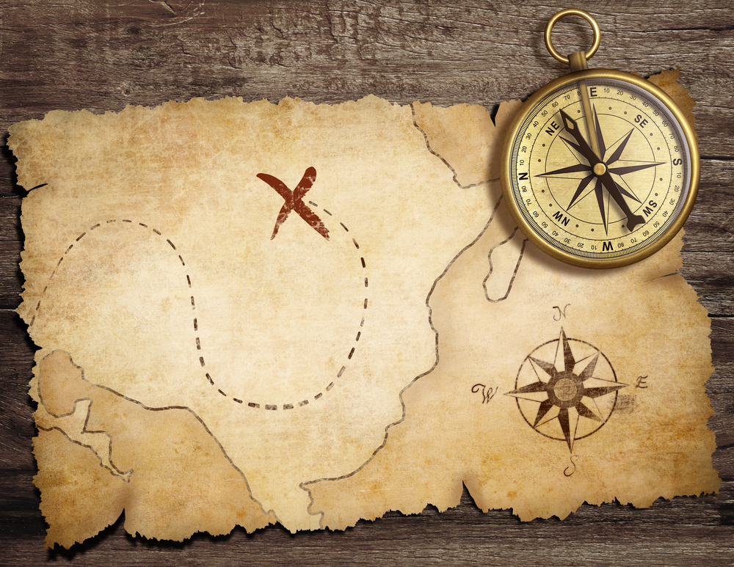
- What colour is the Australian 20 dollar note?
- When did Cadbury launch the world famous Dairy Milk Bar?
- What is one of the Google trend topics of today. i.e Most Googled things today?
- On the TOYSRUS website how much is the Chewbacca Electronic Mask
- Find me a picture of a bush baby.
- What day will be the opening ceremony of the Rio Olympics?
- On YouTube search for the cat that barks like a dog. Watch it and send through a screen shot.
- Find me a picture of sharknado.
- Find and watch the karaoke clip Sharon Wilson dipped in snakes. Watch it and send through a screen shot.
- Who are the current judges on the Australian version of the Voice?
- How much is the new iPhone SE 64GB on the apple website?
- How many times is the phrase “let it be” used in the Beatles song, Let It Be?
- Send a link to recipe for Churros.
- How many victims did Jack the Ripper have?
- Screen shot Brisbane, Australia on Google Maps
- What colour is a Witchetty Grub?
- Accroding to the Guinness World Records, how long was the longest videogame marathon on World of Warcraft?
- Screenshot a picture of the Chinese Crested Dog.
- What is the top news story of the morning on BBC?
- What is a Pavlova?
- Screenshot the Education Links vision statement video from the school website.
- What is the world population today?
- Who is the highest paid footballer in the world?
- What happened today in history?
- How many seasons have there been of The Simpsons?
- When is Beyonce’s birthday?
- How many legs does a Numbat have?
- What is the weather like in Tokyo today?
- When was the Internet created and by whom?
- Attach your favourite of Leonardo Da Vinci’s inventions.

